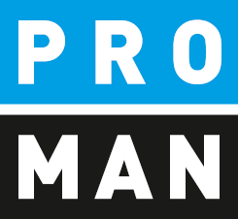
PROMAN Software GmbH
Software for Project Management
and construction project management

PROMAN meeting report
QuickStart:
- Create project
- Creating Addresses
- First protocol
- Report printing
- Sending email

Version 4.2
December 2022

table of contents
1. General information 3
2. Create project 3
2.1. Change Logo 6
3. Creating Addresses 7
3.1. Creating Addresses Centrally 7
3.2. Use addresses in a project 10
4. Rename Report Collection 10
5. My first report (Minutes) 12
5.1. Create and edit report items 15
5.2. Pictures and attachments 17
6. Print report (PDF) 21
7. Print out the report and send it to the distribution list as an e-mail 22
8. Further functions 24
9. Layout and print settings 24
10. Proman Support 24

General information
In this document you get all necessary information necessary to create your first project successfully. This includes:
- Creating a project
- Transferring the print settings from another project (template project)
- Creating addresses
- My first collection of reports and minutes
- Printing and emailing of the protocol

All descriptions are valid from software version 4.2.22 If you have an earlier version, please contact the hotline (+43 1 478 05 67) to install the latest update.

Create project
With a left mouse button click on the menu File / New / Project to create a new project.
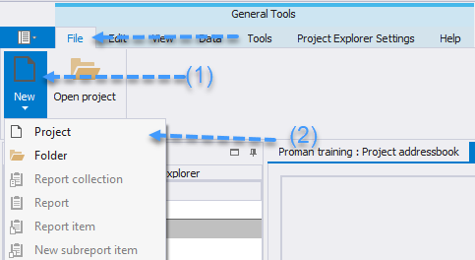
This opens the following mask:
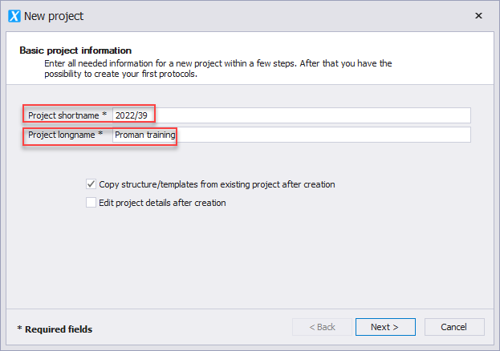

Field description:
- “Project shortname”: enter the short form of the project here (e.g. project number)
- “Project longname”: The project heading is entered here.
- Edit project details directly after project creation (optional)
- Apply project structure/templates... (optional)
Please select " Copy structure/templates from existing project after creation".
With the button "Next" we get to the following mask:
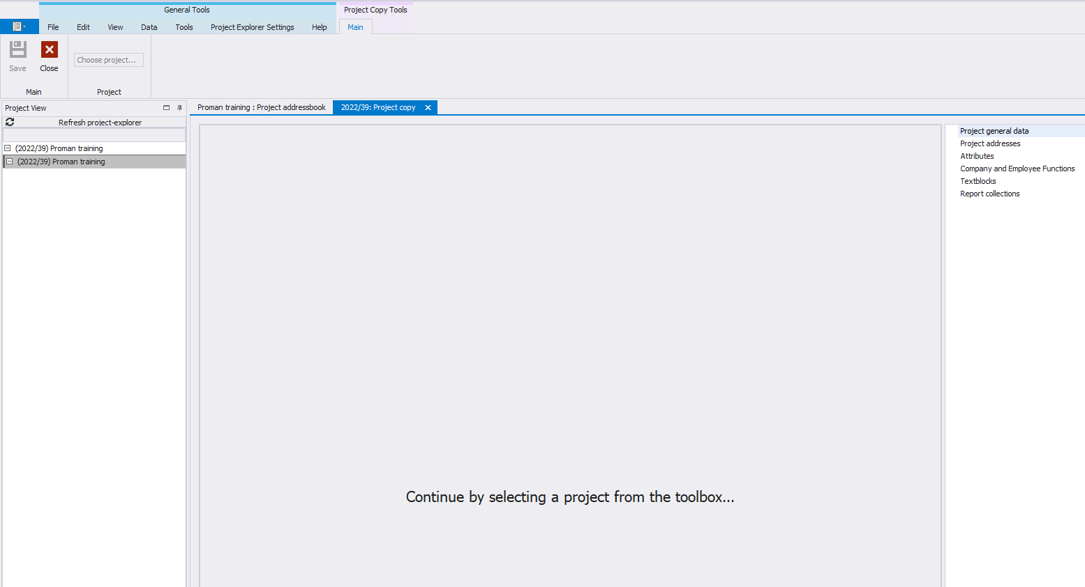
This allows us to easily copy the following elements from an existing project (template project / sample project):
- logo
- font
- standard text blocks (e.g. opposition deadlines, e-mail text for protocol dispatch)
- whole report collections (e.g. construction meeting, building owner meeting) incl.
  - chapter structures
  - point status
  - print settings
In the following screen we can decide what should be copied. Since it is a copy, we can change all this data afterwards.
I also recommend these steps if you only have the included example project.
We can also copy these settings and data after we have created a project.
The currently created project is opened automatically. For this purpose, the selection mask for the "Adopt project structure from existing project" is also opened.
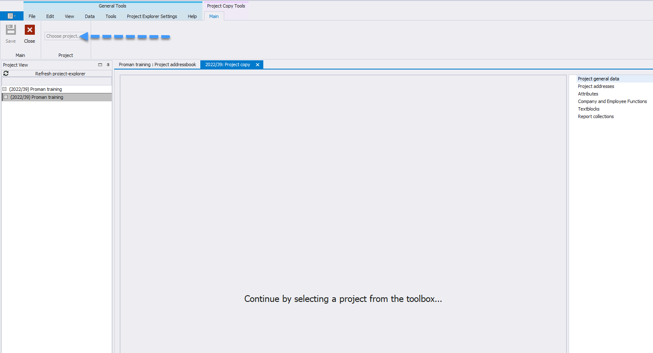
Select the source project from the drop-down menu in the upper left corner. In this example, we use the sample project as a source for our template data.
In the following mask we can adopt individual areas of the template (e.g. logo only), however in the target project we could then remove or modify unused elements.
No item contents are carried over with this function!
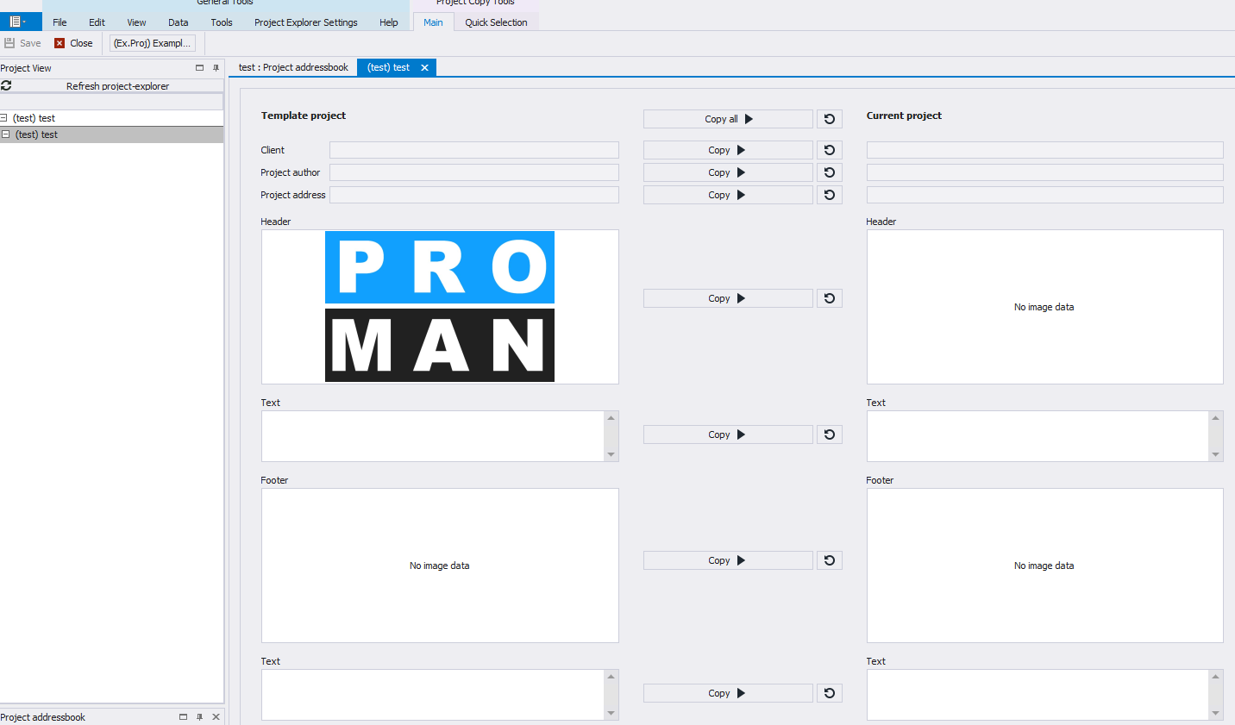

Change Logo
This is done in the "Manage project" mask, which can be reached via the menu bar (1) or via the right mouse button on the project (2). 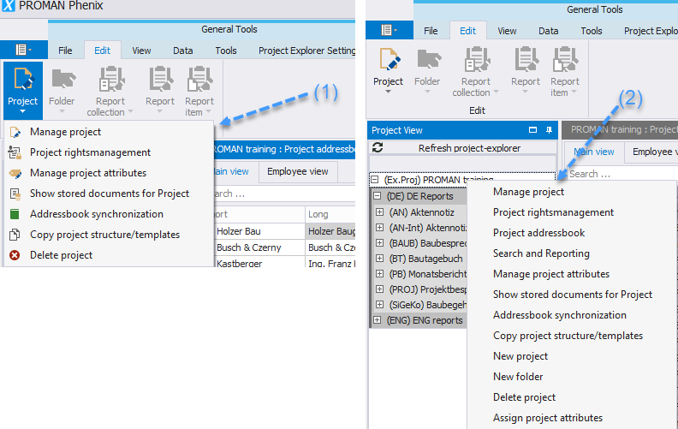
On this page we can change the areas header bar / footer bar / project image. We could also change the project name.
In the header tab we can load the desired new logo with "Load image". We have to define the alignment (right, middle or left) and the logo size in mm on the right side.
The changes can be accepted with "save" or "save & close".
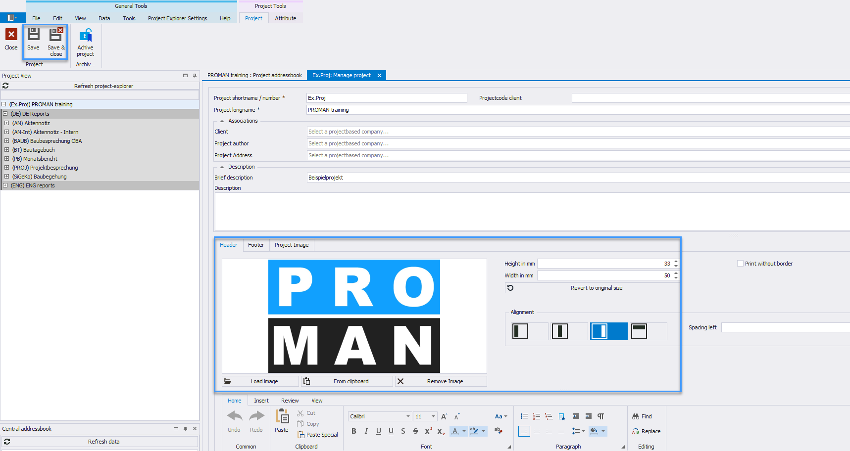

Creating Addresses
When creating addresses, we must first decide whether we want to create them as
- central, i.e. cross-project, or
- in the project
If we create the addresses centrally, they can be used throughout multiple projects.

Creating Addresses Centrally
The central address management can be accessed under tool / show central address book (1):
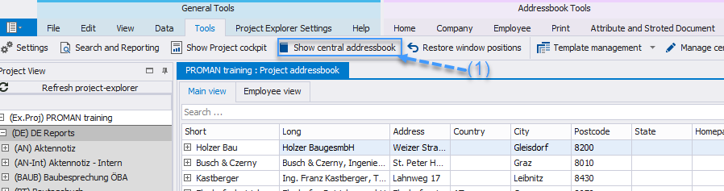
Then another tab "Central Address Book" opens:
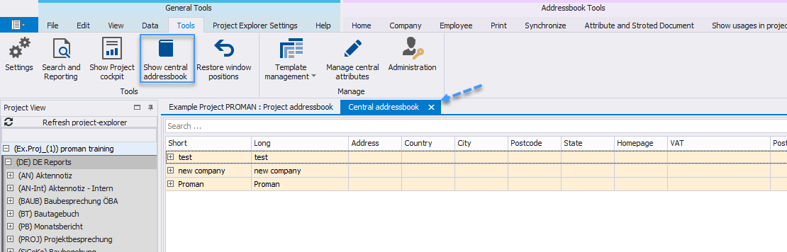
- Addresses created via the Central addressbook are highlighted in yellow to distinguish them from those created via the Project Address Book.

Addresses can be created with the buttons in the toolbox (1) or with the right mouse button at the desired company:
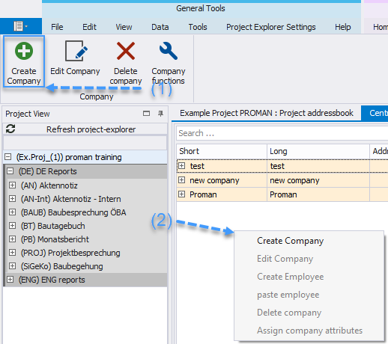
Each person must be created within a company.
To do this, we must first create a company. With the button "Create company" the following mask opens:
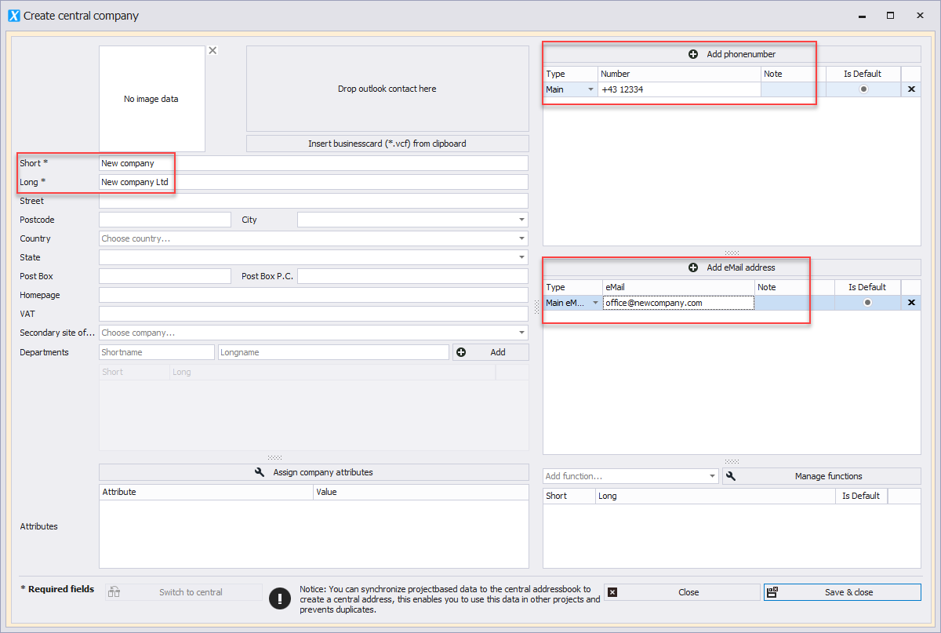
All the recommended fields for the company are marked with red. The remaining fields are useful if you want to use additional information for companies.
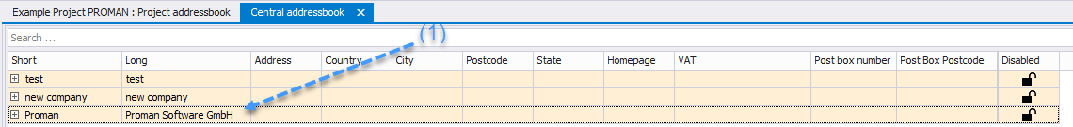
The "Short" field is used for a commonly known short form of the company, e.g.: PROMAN for Proman Software GmbH.
Afterwards, an employee is created via the menu bar (1) or with the right mouse button on a company (2):
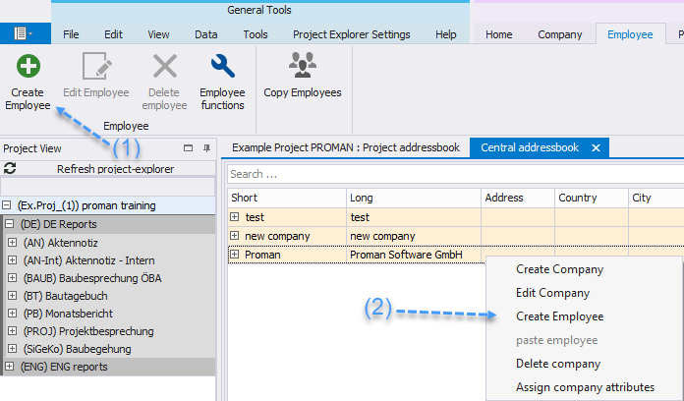
This opens the following mask:
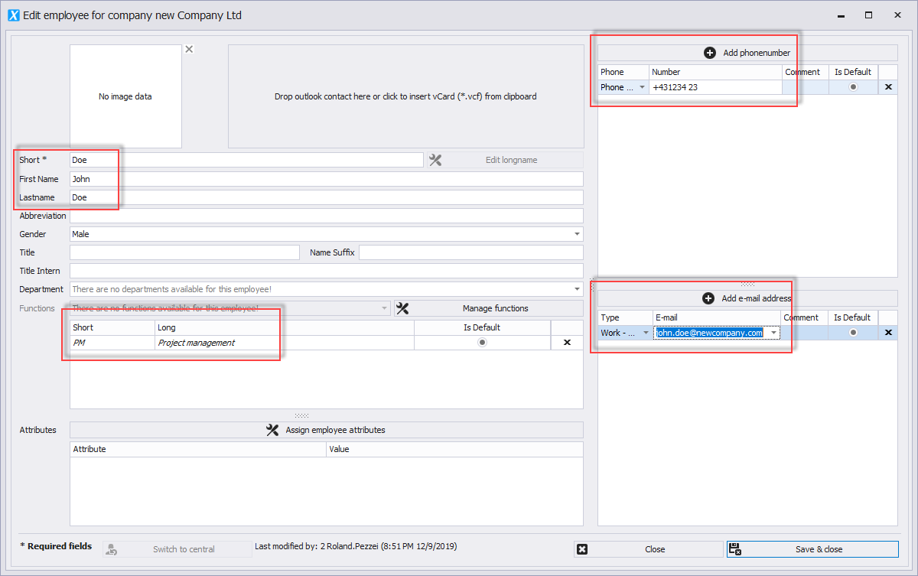
It is recommended to fill in all fields highlighted in red for the employees.
In the "Short" field, please enter a commonly known short form of the person (e.g. last name). This field must be unique per company. (There can be no duplicates).
The function of the employee can be printed directly on the cover sheet in the participant distribution list.
Additionally, the complete Outlook address book can be synchronized if Proman is installed directly on the computer, however Outlook also has to be 32bit. Further information can be obtained from the hotline.

Use addresses in a project
Centrally created addresses can be activated in a project by dragging & dropping. To do this, go back to the "Project Address Book" tab and drag the desired address from the lower left "Central Address Book" window into the “Project Address Book” window, the same thing can also be done by right-clicking on the address: 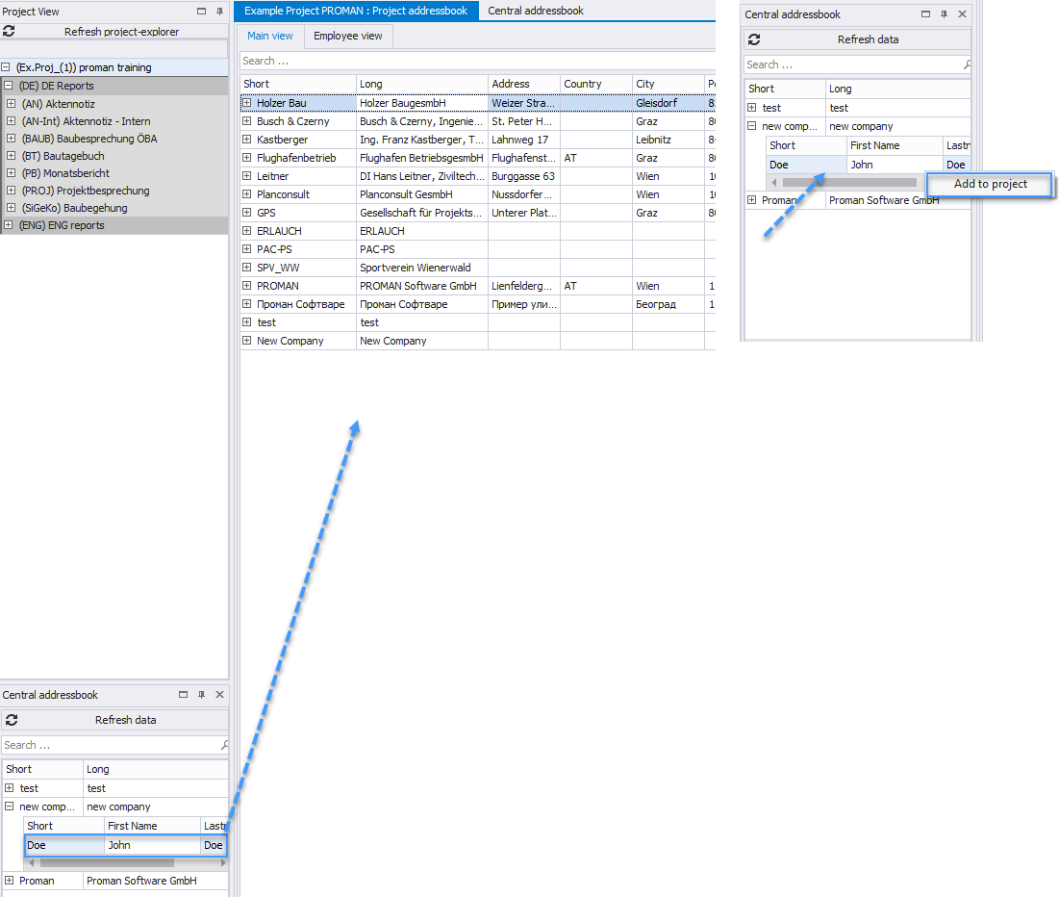

Rename Report Collection
In this example we have copied all report collections from the sample project.
If their names are not suitable, we can easily rename them. We simply right-click on the desired report collection then on "Manage report collection" (1):
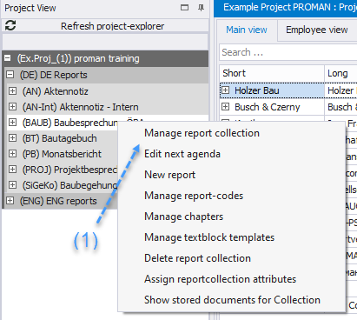
In this case we want to change the "Building Meeting" to "Building Jour Fix":
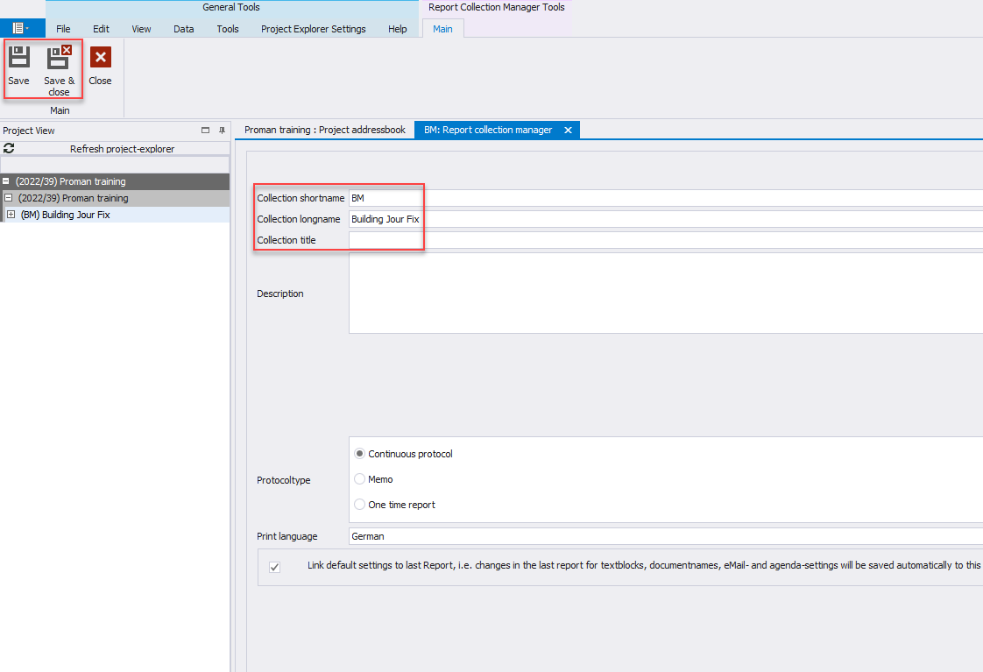
For this we can enter the desired new name in the field "Collection longname ".

My first report (Minutes)
In the desired report collection, please click the right mouse button and select "New report":
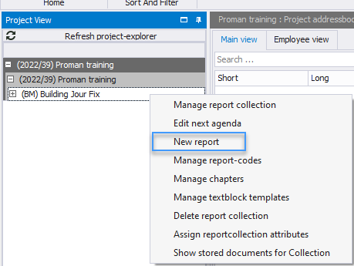
In the following mask please confirm the creation of the new report with "Save & Close". The new report editor then opens:

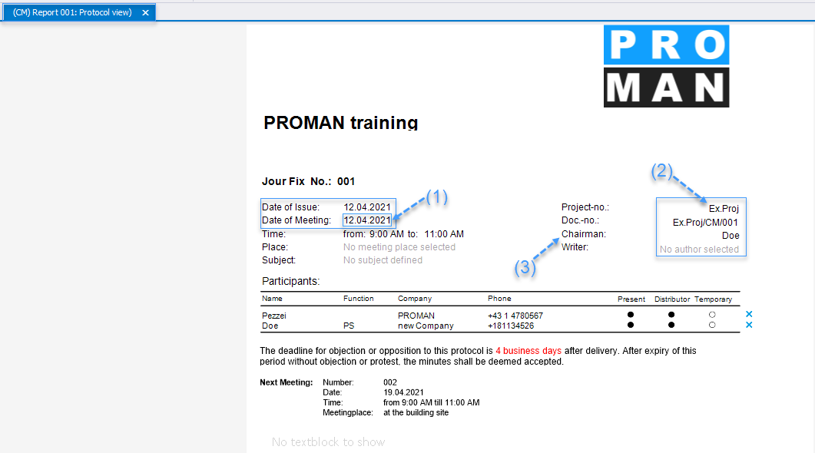
The mask allows to edit the data directly. For example, if we move the mouse button over the meeting date (1), this field will be outlined in blue. If we click on it with the left mouse button, we can edit this field.
In blue there are further control data (2) in addition to the protocol content (e.g. to the right of the leader / author there is an X to delete the person).
If you want to set Mr. Doe as the leader (3), you can simply drag and drop this person into the Chairman field, or drag him into the Participant and Distributor fields or as participant and distributor:

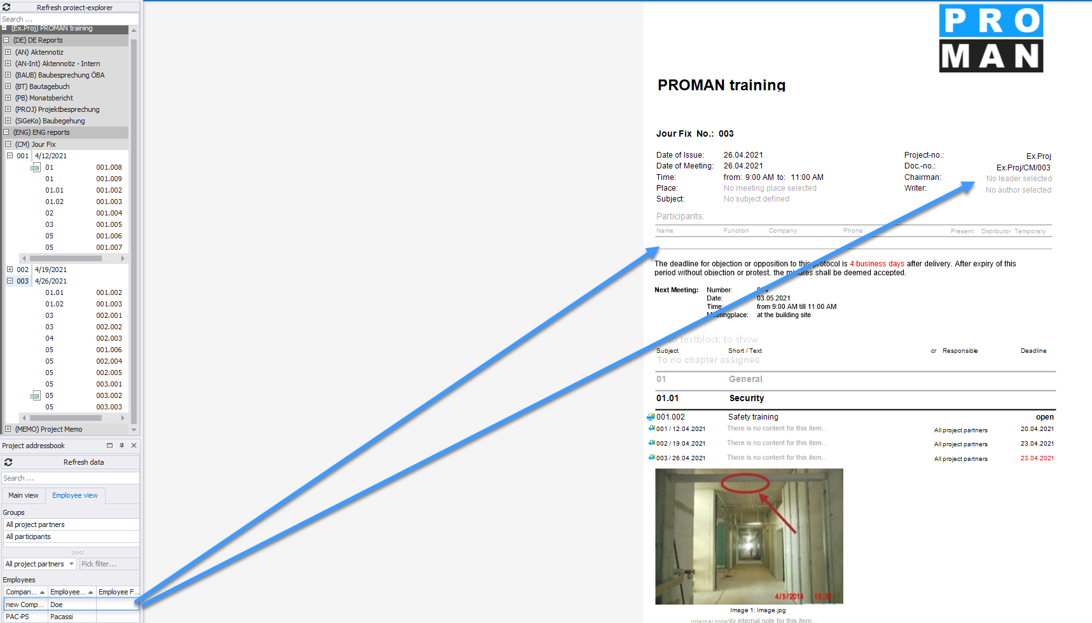
"Leader" or "Writer" can be removed with the left mouse button:
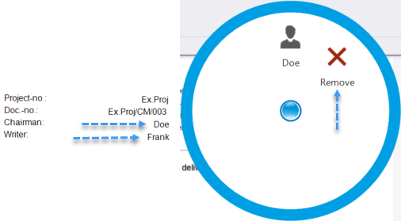

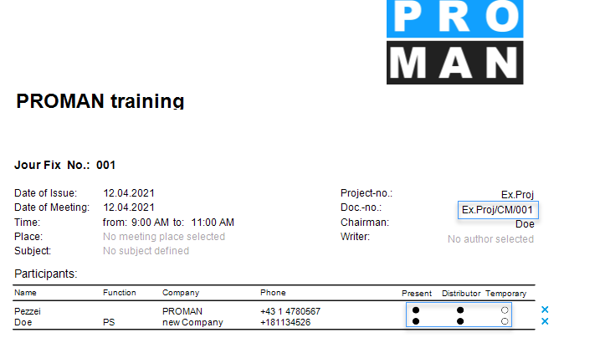
In the participant distribution list, we can change the status for present, distribution list (Distr.) or present temporarily (temp.) simply by clicking on the bead.

By right-clicking on the participants list you can also edit participants sorting:
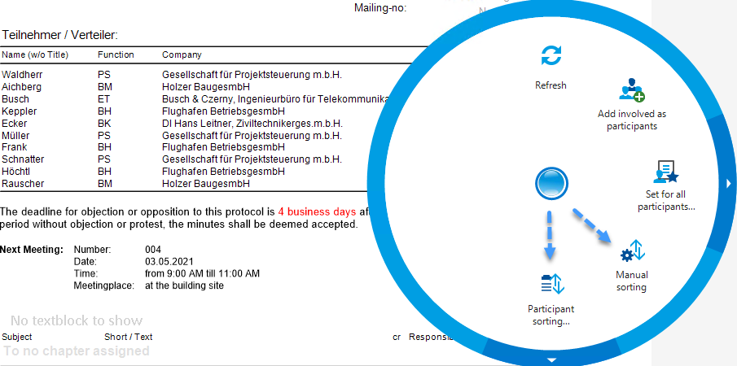

Manual Sorting:
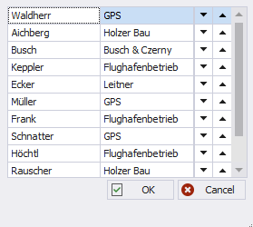
Automatic Sorting:
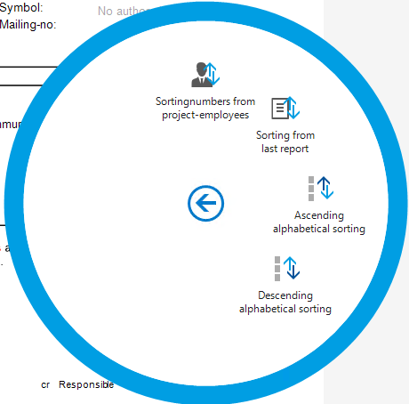

Create and edit report items
In the same mask, below the cover sheet, we can edit the protocol points right away. In our example, there are already chapters. These were taken over from the example project - they can be changed or deleted. In the menu there is a button "Edit chapter". An item in the General chapter can be created by clicking with the right mouse button on the chapter heading (1).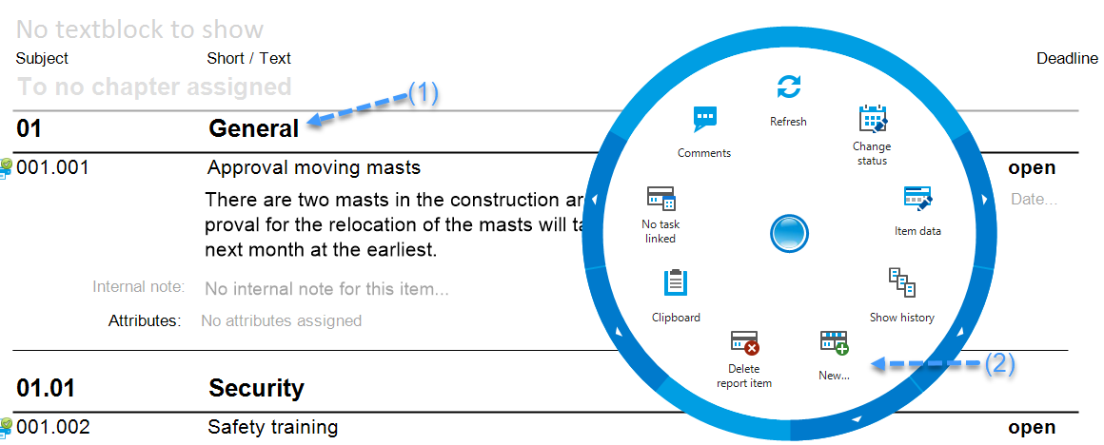
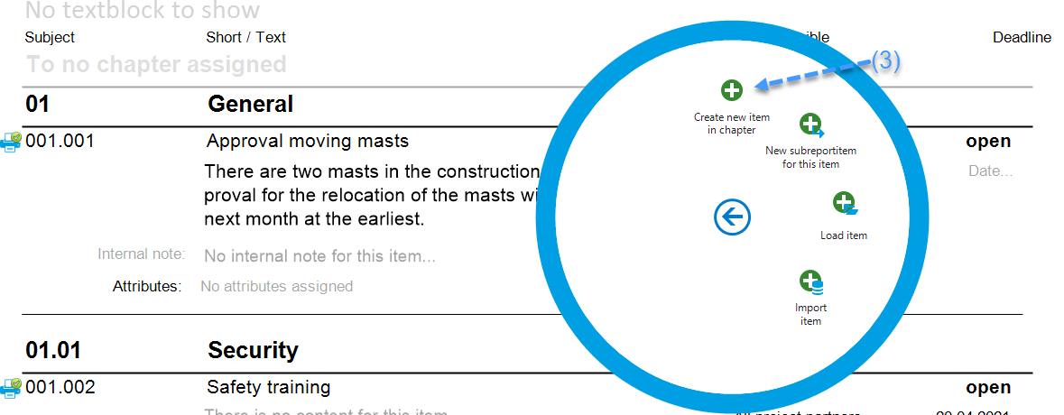
The report item heading, called item short, and report item content can be opened with a left mouse click:
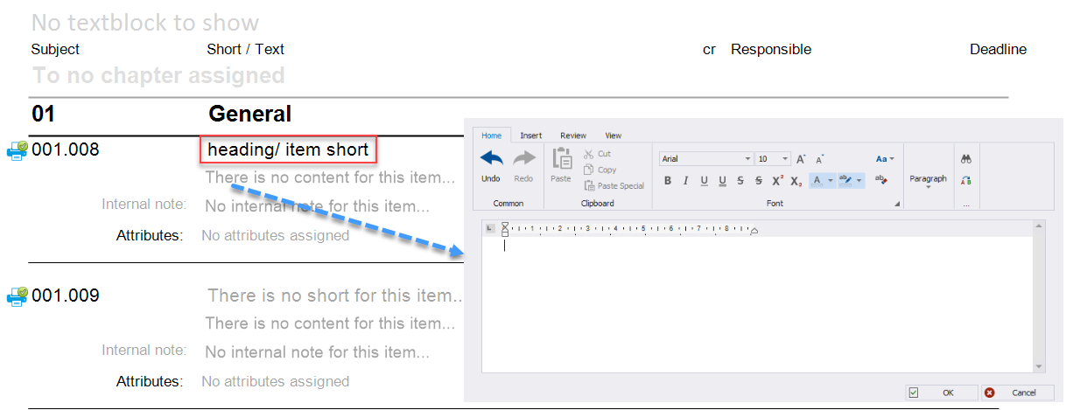
Statuses:
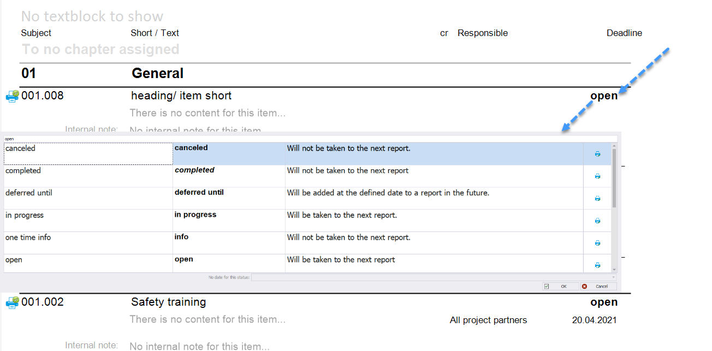
This list of statuses can be applied as desired in the report collection.
The status also determines whether a report item is included in the next report.
According to the description, an open task is taken to the next report. On the other hand, a completed task is printed in the current report, but is not included in the next report.
Use this feature to structure reports, thus avoiding having to painstakingly delete points.
We can assign a leader by dragging the desired person into the report item:
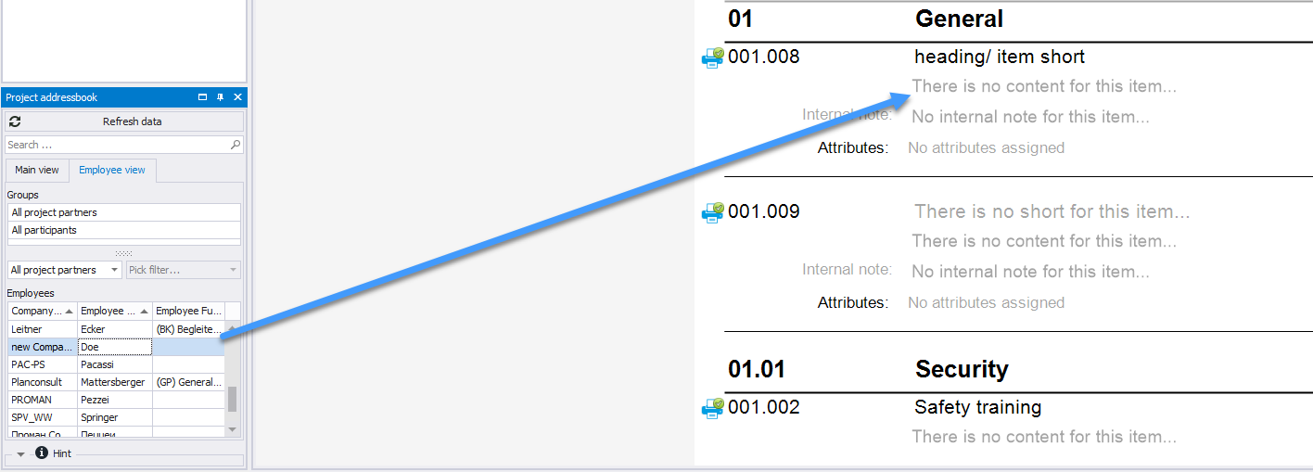
Then we can also set a completion date by clicking on the date field to the right of the responsible person:

Pictures and attachments
Images and attachments can also be added into the report item by right-clicking on the item and selecting Clipboard (1):
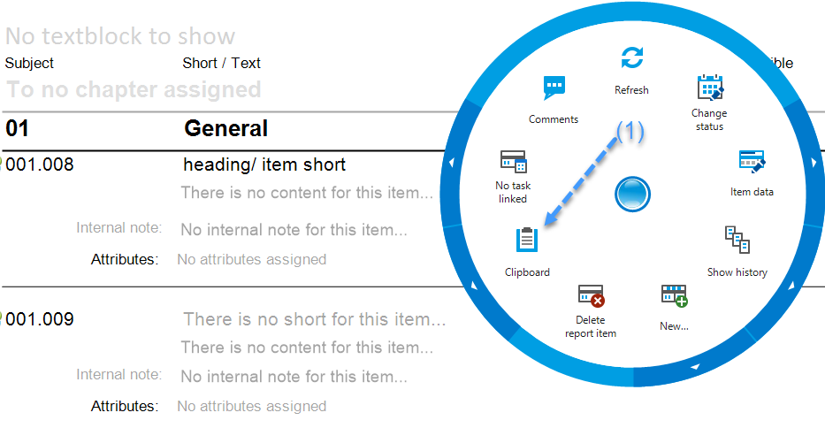
Assuming that the desired attachment is already on the clipboard, just select paste (2) to have it added.
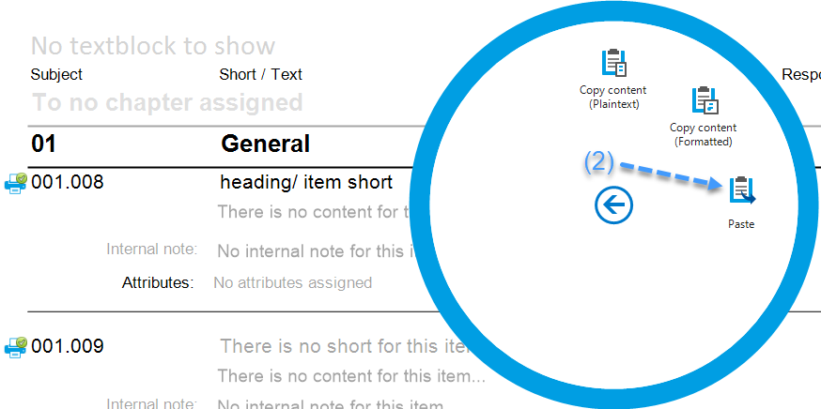
These images can then be further edited (e.g. to highlight damage) by right-clicking them and opening the Image Editor:
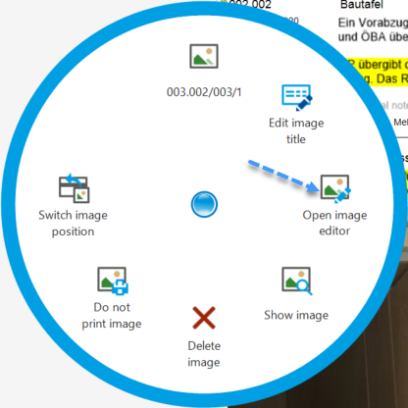
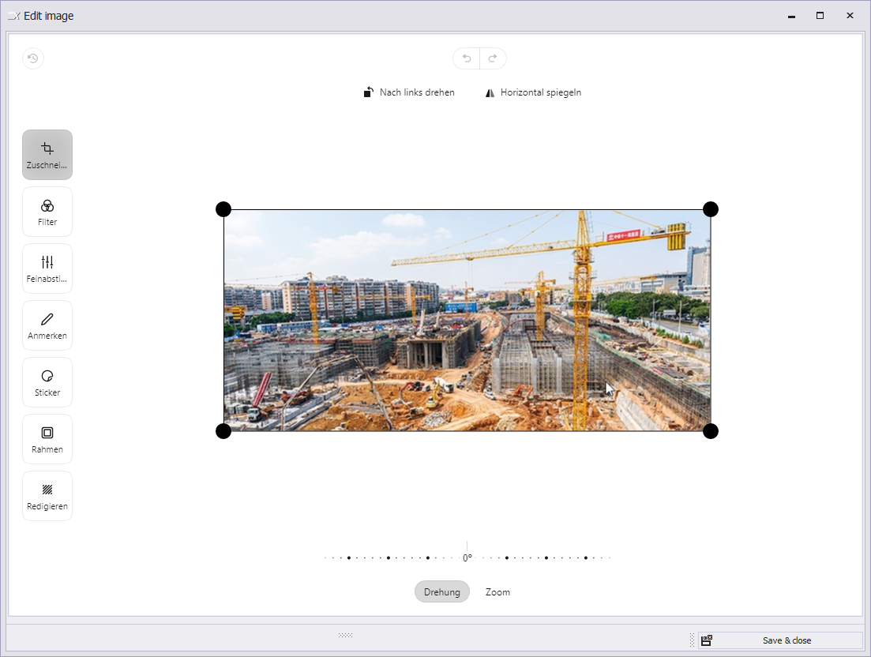
TIP: If we want to add a plan, for example, we can simply copy the desired image section from a DWG or PDF plan file using the Windows tool "Snipping Tool" and paste it into the meeting report using the Paste button.

There is no limit to the number of images per point.
If you want to insert a plan, for example, you can simply copy the desired image section from a DWG or PDF plan file using the Windows tool "Snipping Tool" and paste it with the insert button (the same as inserting an image).
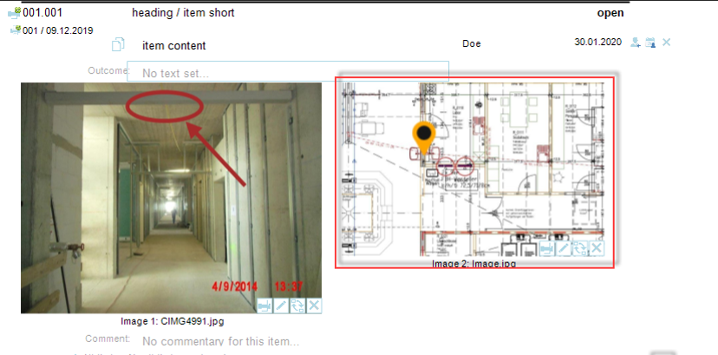
In the editor a pin can be placed directly with the pen at the desired position.

In a similar manner, PDF documents can also be added to the report. A legend of the attachments can be created automatically.
The PDF documents are automatically added to the PDF file according to the report and are stamped with the corresponding report item number, e.g.
We have added the following attachments to the point:
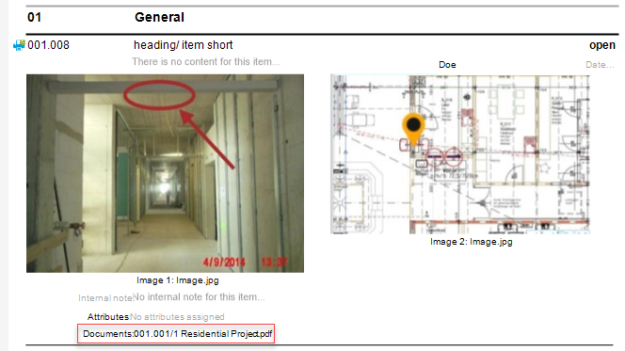
This PDF is attached after the protocol and stamped with the point number 001.001 in yellow:
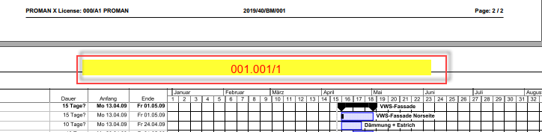

Print report (PDF)
When our report is finished, we can simply create a PDF using "Print report as pdf":
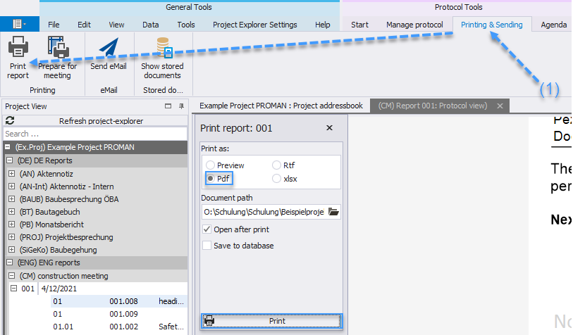
Alternatively, we can send the reports by e-mail. More details can be found in the following chapter.

Print out the report and send it to the distribution list as an e-mail
With the function "Send e-mail" the following is automatically carried out:
- PDF output with attachments
- Standard subject and text for your email
- Distribution list automatically filled according to the distribution list
- The finished e-mail will be opened automatically in your e-mail client (e.g. Outlook) for a check before sending it out.
The first step for this is the function "Send e-mail" (1):
Subject as well as e-mail text will be loaded with the predefined settings and text:
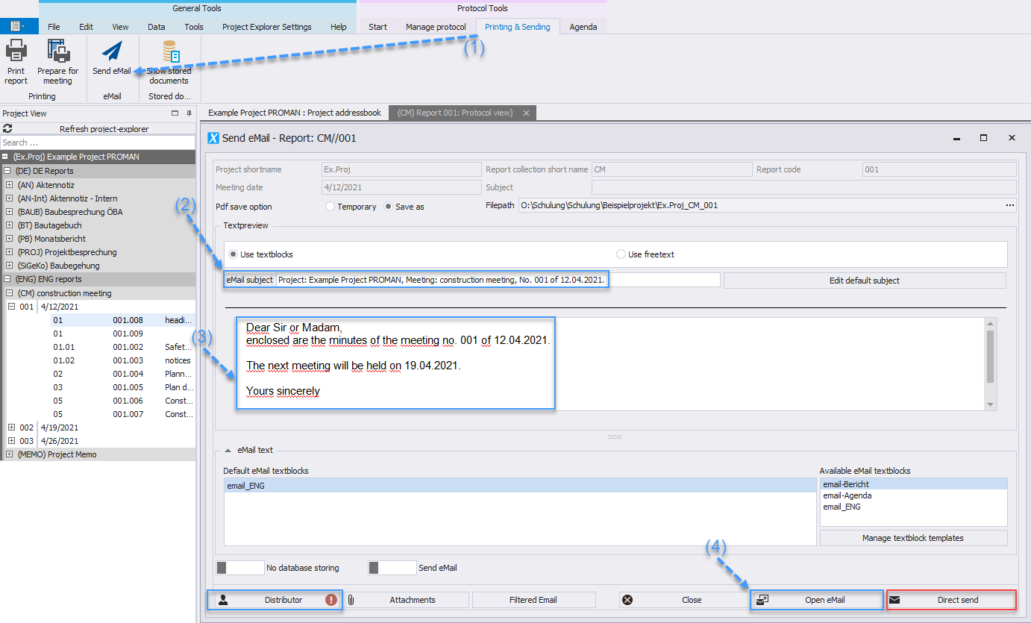
Subject as well as email text are loaded with the predefined settings & texts:
The subject (2) is created using macro fields ("Edit default subject" function). E.g., the session date and session number can be filled automatically with this.
The same applies to the text content of the e-mail (3).
The software adds all persons to the mailing list who have been defined in the participant/distributor list and who have an e-mail address. Further recipients can be added to the mailing list later (4).With the button "Open e-mail" the PDF file of the protocol is created, stored and the e-mail is filled with all the data.
If attachments have been moved or deleted, you will be informed about it and still have the possibility to correct them before sending.
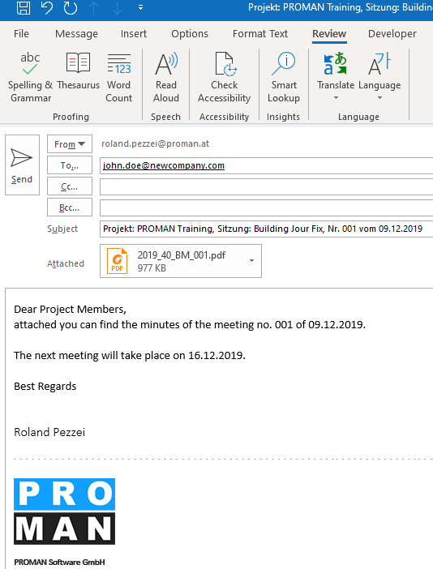

Cloud:
In our cloud version, there is an intermediate step that appears just like when you create a PDF document after "Open Email": an .eml file is created for the email, which you can download and open in Outlook.

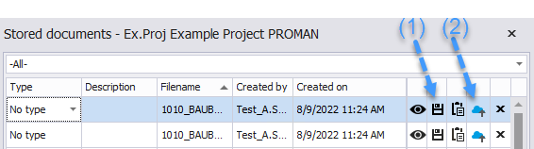

Here you can find all saved documents of the selected report collection.
You can either copy the document to the clipboard using the button (1) and place it on the desktop, for example, or create a link using the button (2) and open it in the browser and download the desired file.

Further functions
The application also supports many other functions:
- Search and reporting to find or to print out sub-areas of protocols
- Agenda and invitation
- Prepare meeting with your own comments for each item
- Live logging with beamer view
- Import points from external cross-referenced sessions
- ..

Layout and print settings
Further information on the possible layouts and print settings can be found directly in the training documents of your version:
https://www.proman.at/proman_x_releases/currentversion/

Proman Support
If you have any questions, our team at the hotline will be happy to answer them:
support@proman.at
International or AT +43 1 478 05 67
from Germany 0800 589 0129
We are happy to support you.

