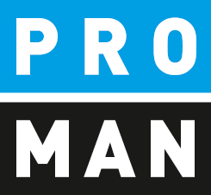
PROMAN Software GmbH
Software for Project Management
and construction project management

PROMAN meeting report
QuickStart:
- Create project
- Creating Addresses
- First protocol

Version 1.00
October 2019

table of contents
1. General information 3
2. Create project 3
2.1. Change Logo 6
3. Creating Addresses 7
3.1. Creating Addresses Centrally 7
3.2. Use addresses in the project 11
4. Rename Report Collection 12
5. My first report (Minutes) 13
5.1. Create and edit report items 16
5.2. Pictures and attachments 18
6. Print report (PDF) 21
7. Print out the report and send it to the distribution list as an e-mail 21
8. Further functions 23
9. Layout and print settings 24

General information
In this document you get all necessary information to create your first project successfully. This includes
- Create a project
- Transfer the print settings from another project (template project)
- Create addresses
- My first collection of reports and minutes
- Printout and eMail of the protocol

All descriptions are valid from software version 3.3. If you have an earlier version, please contact the hotline (+43 1 478 05 67) to install the latest update.

Create project
With a right mouse click on the menu File / New / Project you can create a new project.
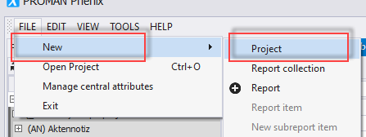
This opens the following mask:
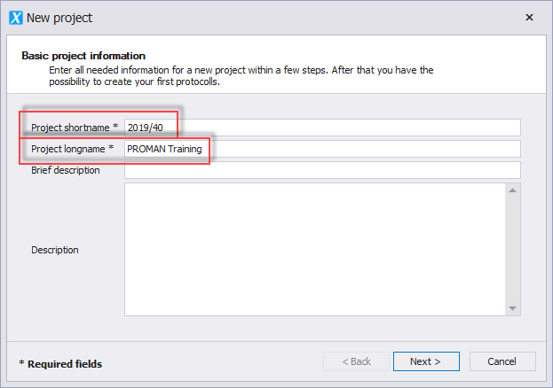

Field description:
- “Project shortname”: enter the short form of the project here (e.g. project number)
- “Project longname”: The project heading is entered here.
The remaining fields are optional.
With the button "Next" you get to the following mask:
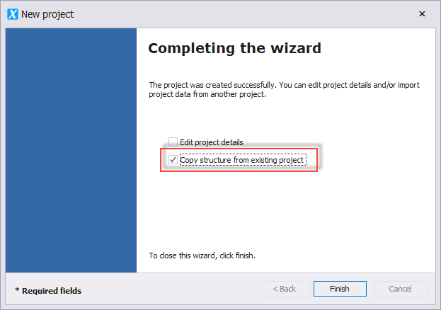

Please select "Copy structure from existing project".
This allows you to easily copy the following elements from an existing project (template project / sample project):
- logo
- font
- standard text blocks (e.g. opposition deadlines, e-mail text for protocol dispatch)
- whole report collections (e.g. construction meeting, building owner meeting) incl.
  - chapter structures
  - point status
  - print settings
In the following screen you can decide what should be copied. Since it is a copy, you can change all this data afterwards.
I also recommend these steps if you only have the included example project.
You can also copy these settings and data after you have created a project.
The currently created project is opened automatically. For this purpose, the selection mask for the "Adopt project structure from existing project" is also opened.
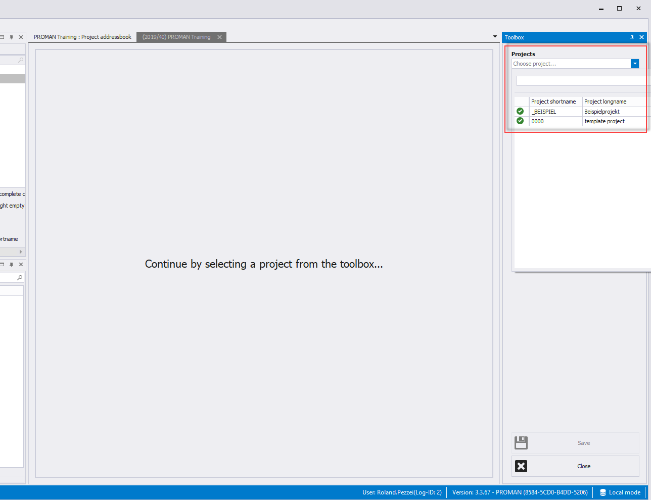

Select your source project in the right area. In this example, we use the sample project as a source for our template data.
In the following mask you can adopt individual areas of the template (e.g. logo only).
I recommend that you use the button "All data without project participants" to transfer all template data.
In the target project you can then remove or modify unused elements.
No item contents are taken over with this function!

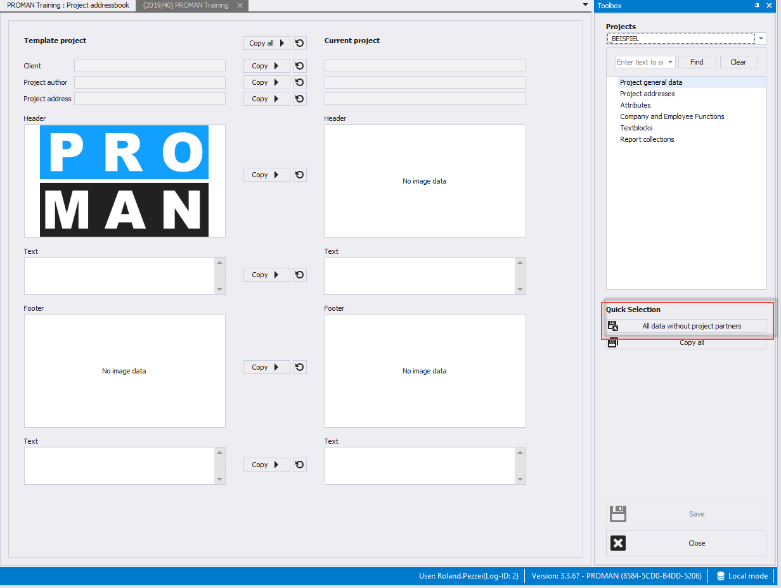

Change Logo
If you have taken the data from the example project, you will surely want to change the logo.
Right-click on the project, in this case on "(2019/40) PROMAN Training", then on "Manage project":
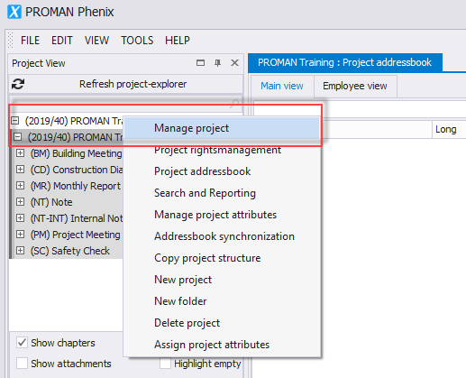

On this page you have the possibility to change the areas header bar / footer bar / project image. You could also change the project name.
In the header tab you can load the desired new logo with "Load image". You have to define the alignment (right, middle or left) and the logo size in mm on the right side.
The changes can be accepted with "save" or "save & close".
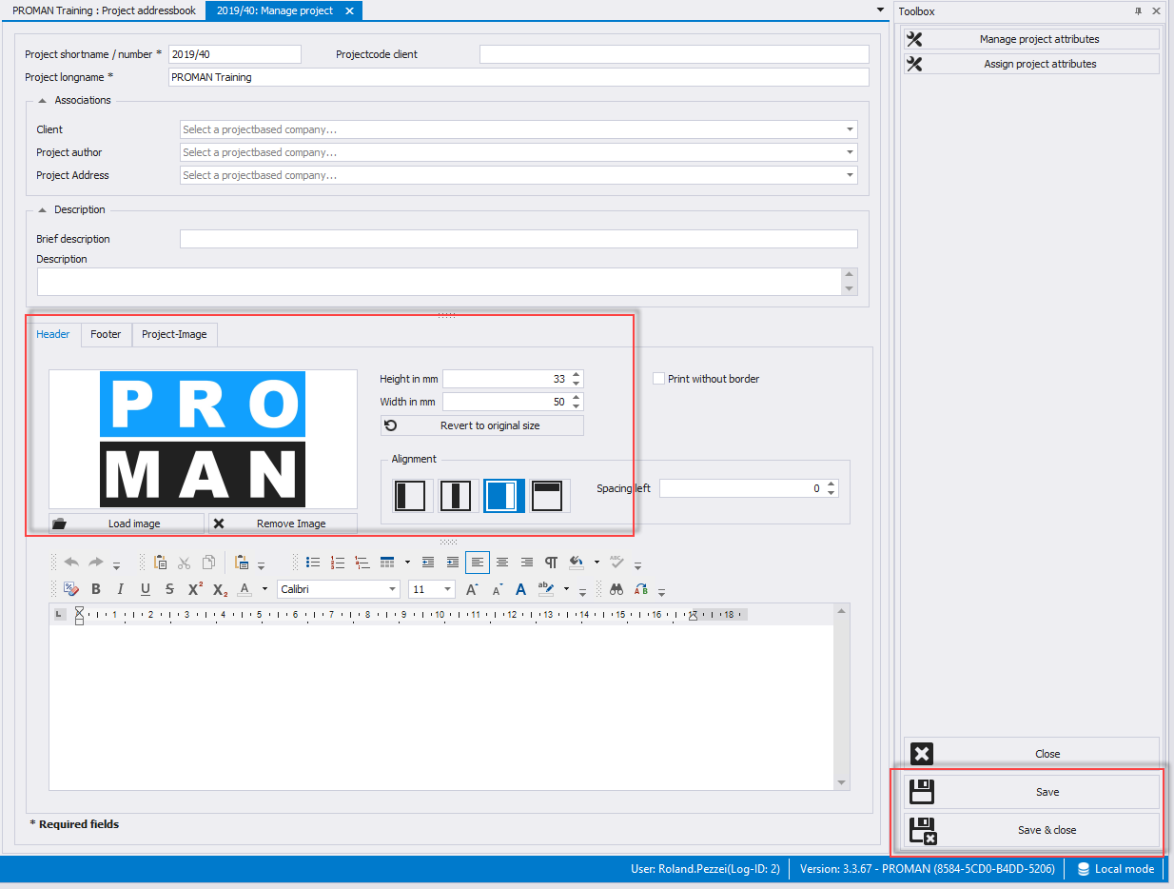

Creating Addresses
When creating addresses, you must first decide whether you want to create them
- central, i.e. cross-project, or
- in the project
If you create the addresses centrally, they can be used for several projects.

Creating Addresses Centrally
The central address management can be accessed under tool / show central address book:
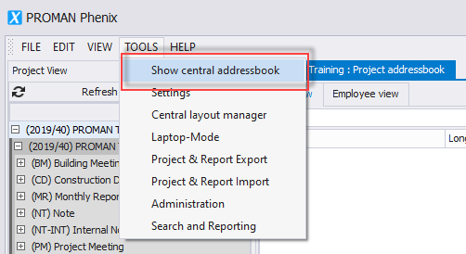

Then another tab "Central Address Book" opens:
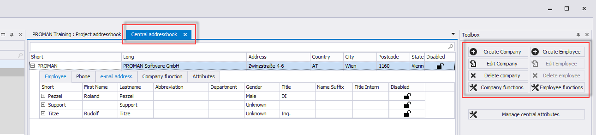

Addresses can be created with the right mouse button at the desired company or with the buttons in the toolbox.
Each person must be created in a company.
You have to create a company first. The following mask opens with the button "Create company":
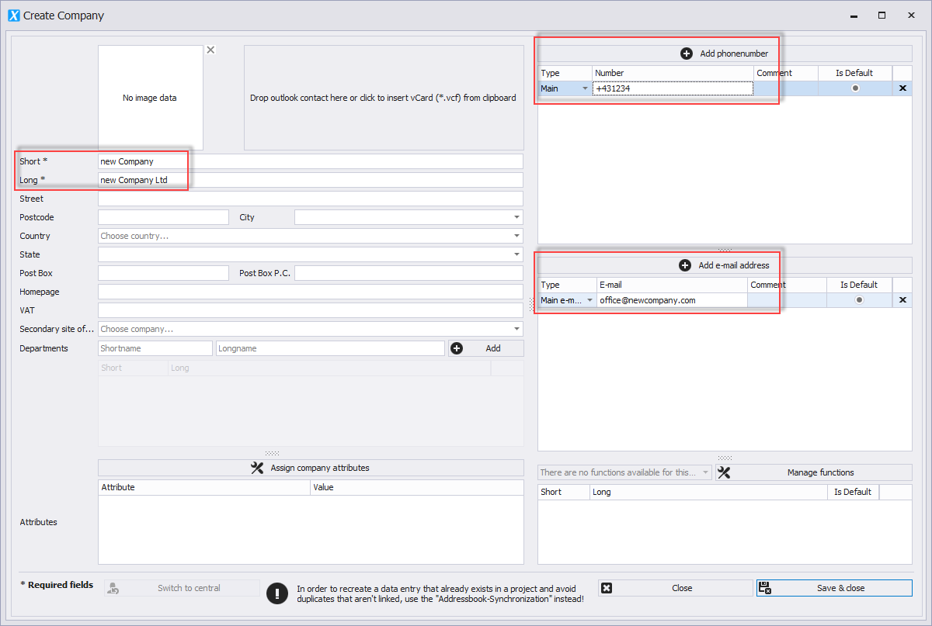

All fields which we recommend for the company are marked with red. The remaining fields are useful if you want to use additional information for companies.
In the field "Short" please enter a generally known short form of the company.
Then use the right mouse button to create a corresponding employee for the newly created company "Create Employee":
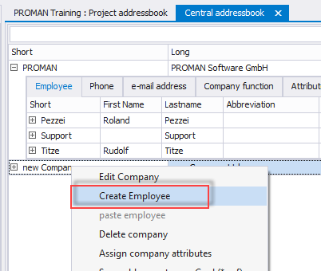
This opens the following mask:
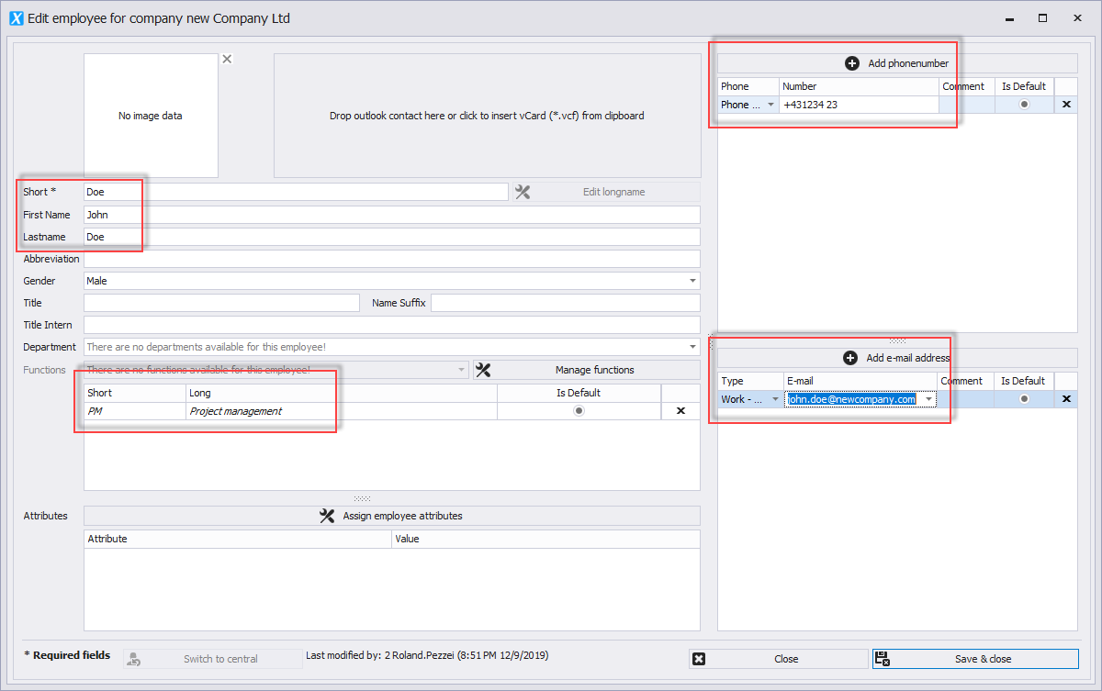

All fields that are to be filled as employees are highlighted in red.
In the field "Short" please enter a generally known short form of the person (e.g. surname). This field must be unique for each company.
The employee function can be printed directly on the cover page in the participant distribution list.
You can also create companies directly from Outlook using drag & drop e.g. you simply drag the desired contact into the field "Drop outlook contact here or ...":
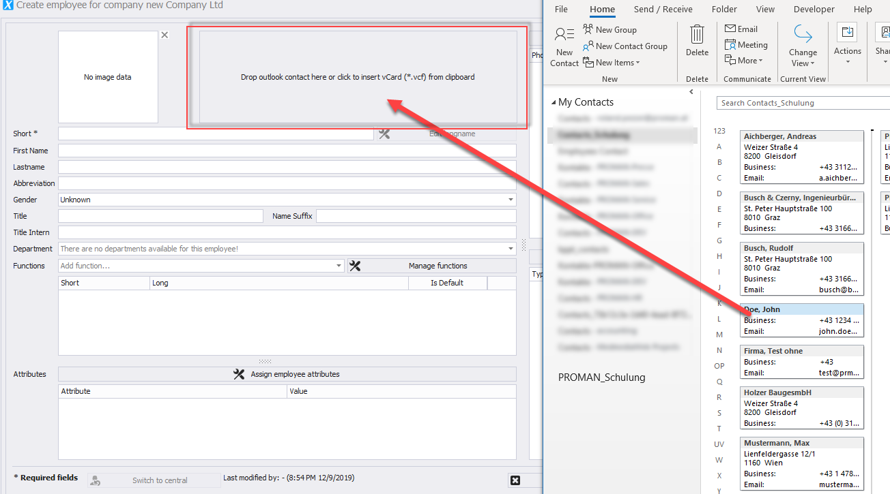

With this method you can create companies as well as employees.

You can also synchronize the complete Outlook address book. Further information can be found in the training documents or if you call the hotline.

Use addresses in the project
centrally created addresses can be activated in the project using drag & drop. To do this, go back to the "Project Address Book" tab and drag the desired address from the lower left "Central Address Book" window into the “Project Address Book” window:
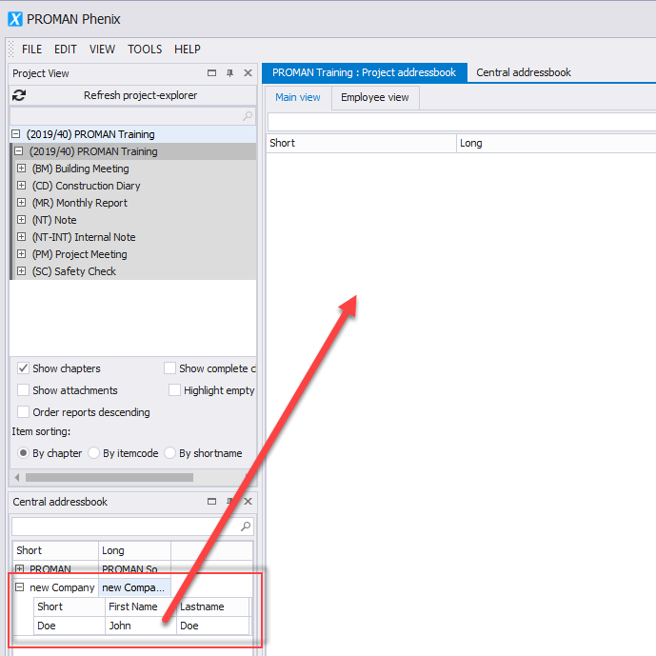
Alternatively, you can do this with the right mouse button:
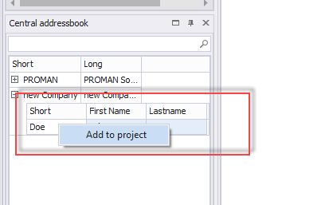

Rename Report Collection
In this example, we have copied all report collections from the sample project.
If the names are not suitable for your project you can rename or delete them.
To rename, simply right-click on the desired report collection and select "Manage report collection":
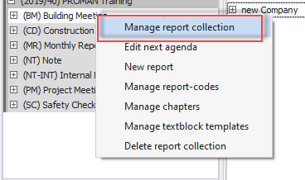

In my case I want to change the "Building Meeting" to "Building Jour Fix":
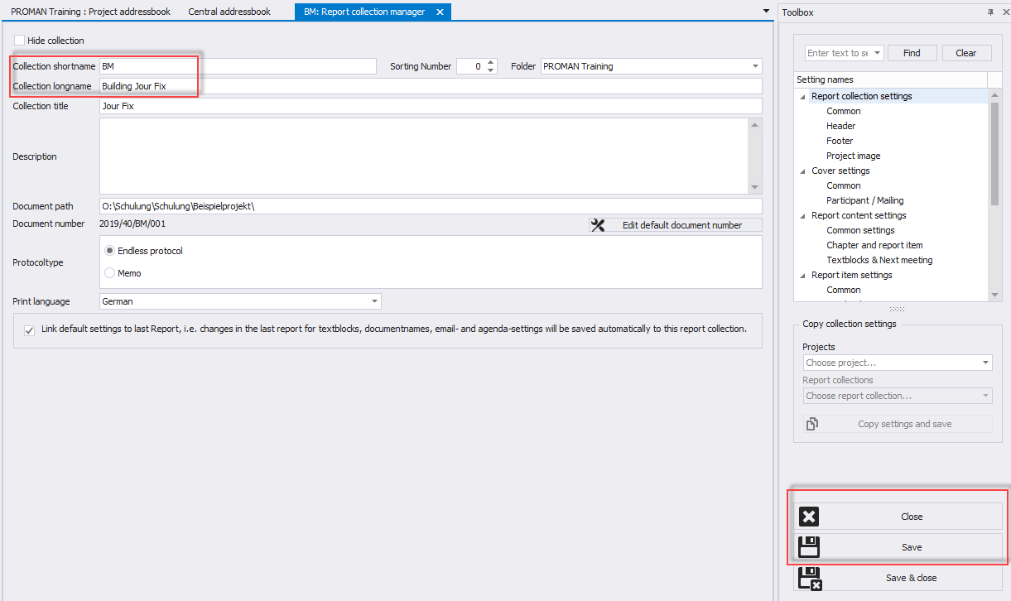
For this I can enter the desired new name in the field "Collection longname ".

My first report (Minutes)
In the desired report collection, please click the right mouse button and select "New report":
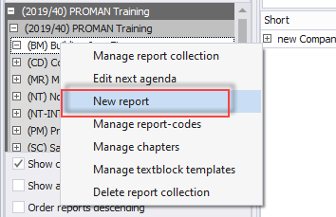
In the following mask please confirm the creation of the new report with "Save & Close". The new report editor then opens:

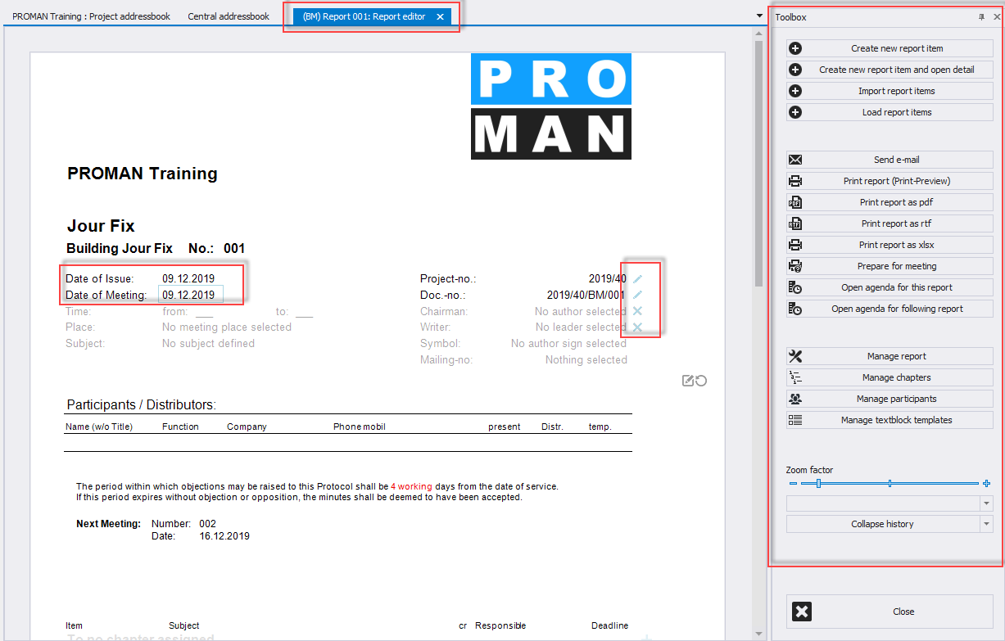
The mask makes it possible to edit the data directly. For example, if you move the mouse button over the “Date of Meeting” field, this field will be bordered in blue. If you click on it with the left mouse button, you can also edit this field.
Further control data are displayed in blue in addition to the protocol content (e.g. the X on the right is for deleting leader / author).
On the far right you have a toolbox with further useful functions.
If I want to put our Mr. Doe as a leader, I can simply drag & drop this person into the leader field:
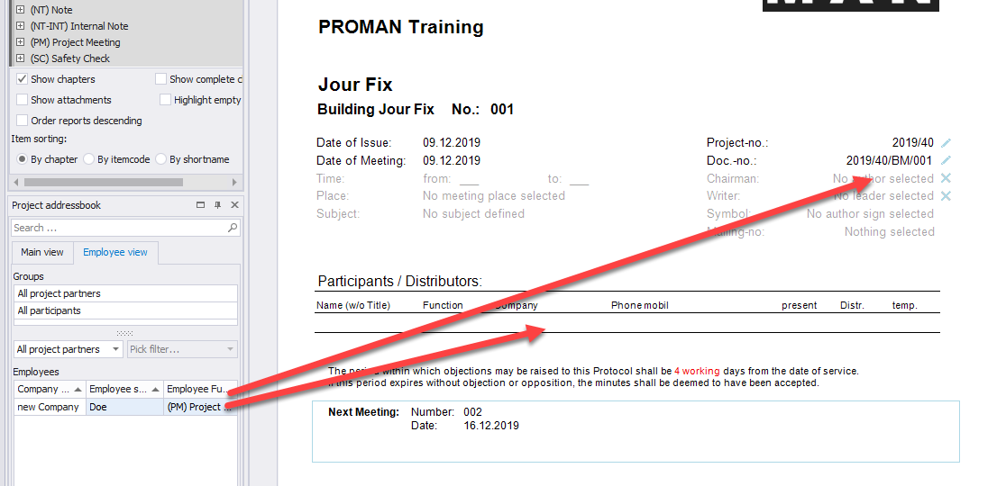

or as participant and distributor.

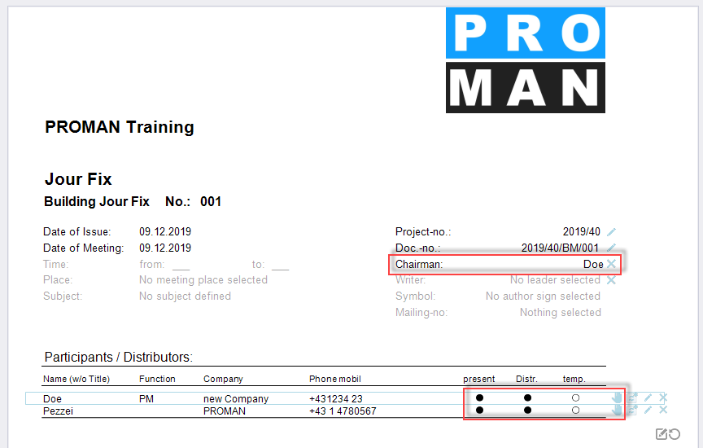
In the participant distribution list, you can change the status for present, distribution list (Distr.) or present temporarily (temp.) simply by clicking on the bead. With the blue hand (far right) you can change the position of the person. You can correct the personal data with the pen (e.g. function, telephone number, etc.)

Create and edit report items
In the same mask you can also edit the report items below the cover sheet.
In our example there are already chapters. These were taken from the example project.
Of course, these can be changed or deleted. There is a "Edit chapter" button in the toolbox for this purpose.

A report item can be created in the chapter “general” using "+" at the right margin of the chapter heading.
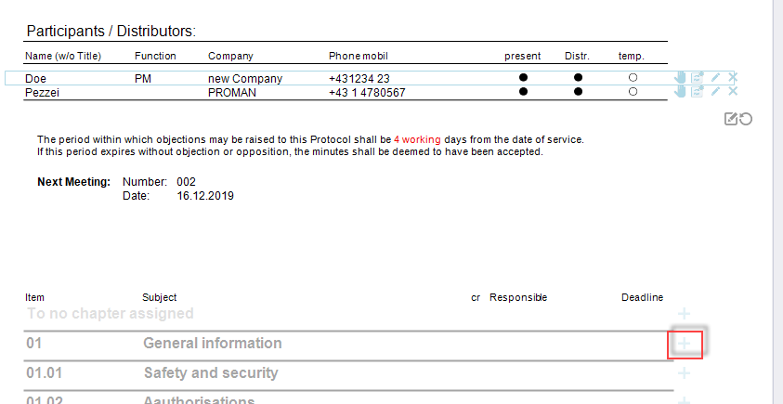
The report item heading, called item short, and report item content can be opened with a left mouse click:
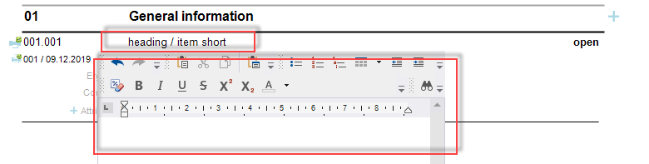

Statuses:
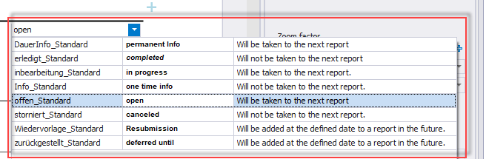

This list of statuses can be implemented as desired in the report collection.
The status also determines whether a report item is included in the next report.
According to the description, an open task is taken to the next report. On the other hand, a completed task is printed in the current report, but is not included in the next report.
Use this feature to structure your report so you don’t have to painstakingly delete points as in Word.
You can put a person in charge by dragging the desired person into the report item:
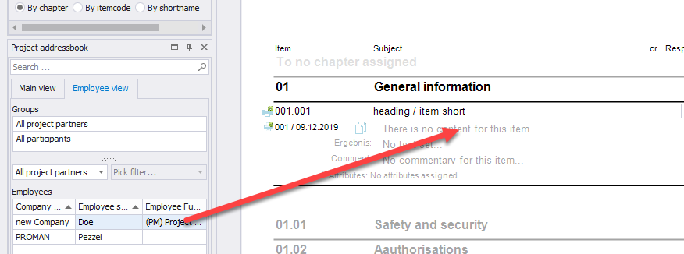

Then you can also set a completion date by clicking on the date field to the right of the currently displayed person:
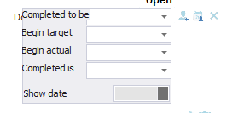

More report items can be created with the small or large plus below the item:
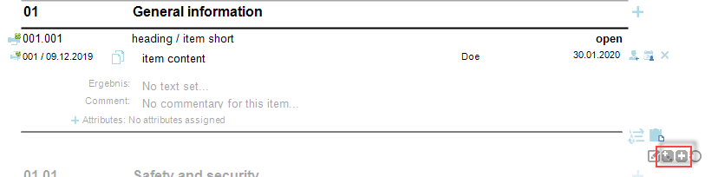

The small plus symbol creates another sub report item. The big plus icon creates a new report item in the same chapter.

Pictures and attachments
Images and attachments can also be inserted into the report item using drag & drop:
Using drag & drop, images and attachments can simply be dragged into the desired item:
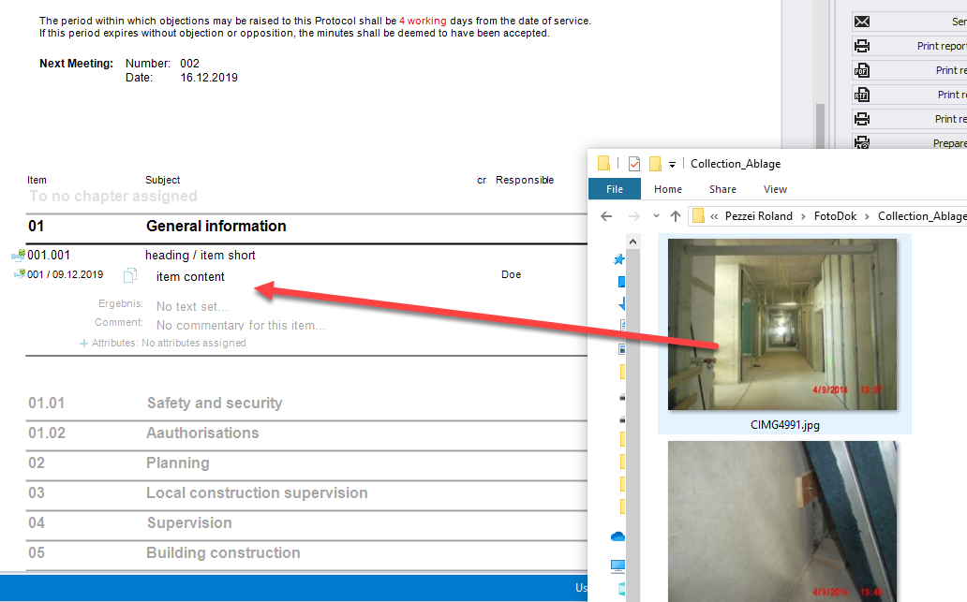

These images can then be further edited with the pen:
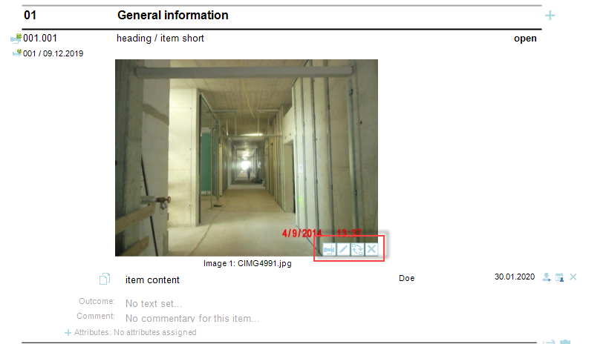

e.g. to highlight damage.

There is no limit to the number of images per point.
If you want to insert a plan, for example, you can simply copy the desired image section from a DWG or PDF plan file using the Windows tool "Snipping Tool" and paste it with the insert button (far right in the image).
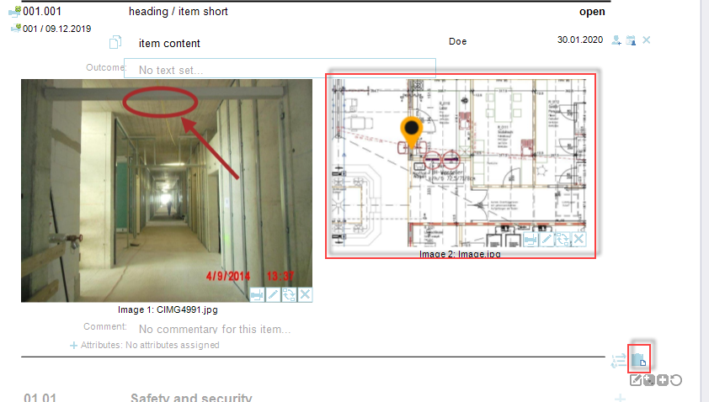

A pin can be placed directly with the pen at the desired position.

Similarly, PDF documents can also be added to the report. A legend of the attachments can be created automatically.
The PDF documents are automatically added to the PDF file according to the report and are stamped with the corresponding report item number, e.g.
We have added the following attachments to the point:
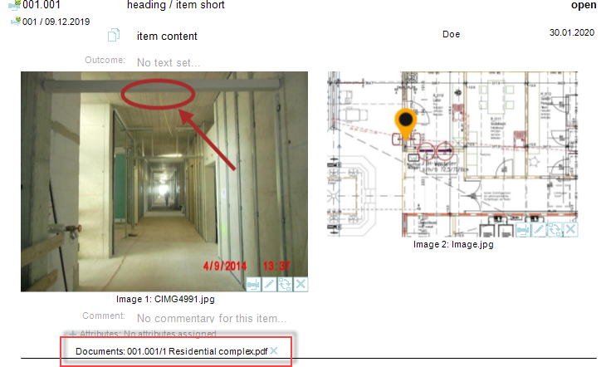

This PDF is attached after the protocol and stamped with the point number 001.001 in yellow:
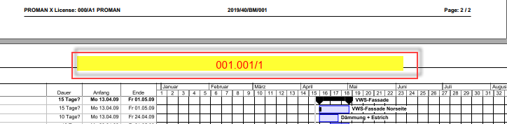

Print report (PDF)
When your report is finished, you can simply create a PDF using "Print report as pdf":
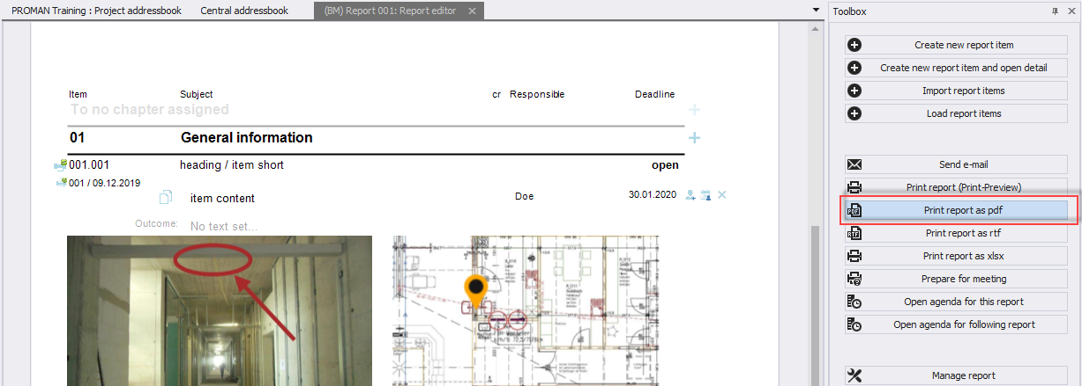

Alternatively, you can send the reports by e-mail. More details can be found in the following chapter.

Print out the report and send it to the distribution list as an e-mail
With the function "Send e-mail" the following is automatically carried out:
- PDF output with attachments
- Standard subject and text for your email
- Distribution list automatically filled according to the distribution list
- The finished e-mail will be opened automatically in your e-mail client (e.g. Outlook) to check it before you can send it.
The first step for this is the function "Send e-mail":
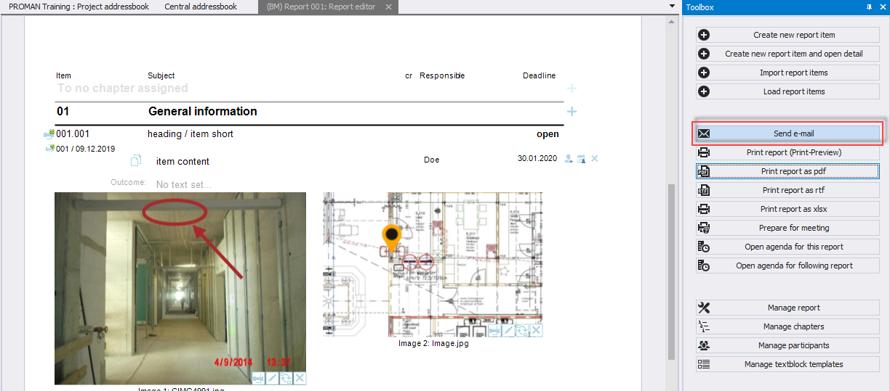

Subject as well as e-mail text will be loaded with the predefined settings and text:
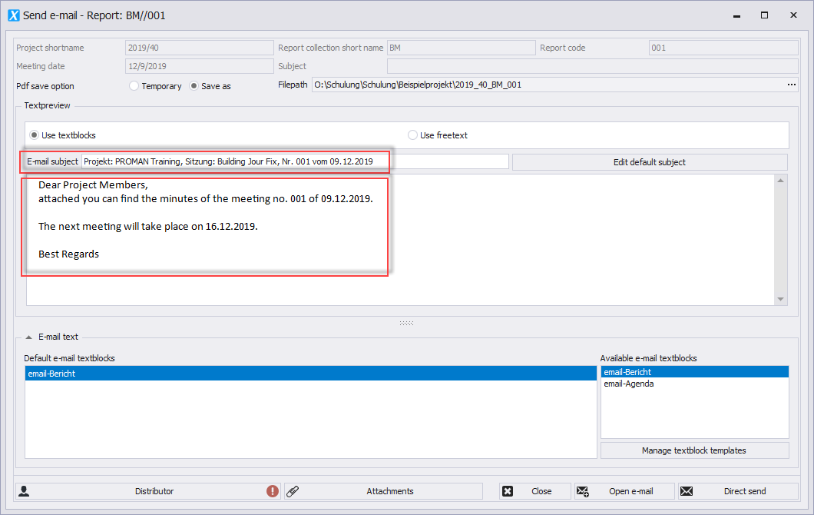
The subject is created using macro fields ("Edit default subject" function). For example, the session date and session number can be filled automatically.
The same applies to the e-mail text.
The software checks if all persons in the distribution list also have an e-mail address.
In this case you will see the following symbol on the distributor list, i.e. one or more persons do not have an email address. If you click on the button, this data can still be corrected temporarily.
If attachments have been moved or deleted, you will also be informed and have the possibility to correct them before sending.
With the button "Open e-mail" the PDF file of the protocol is created, stored and the e-mail is filled with all data.
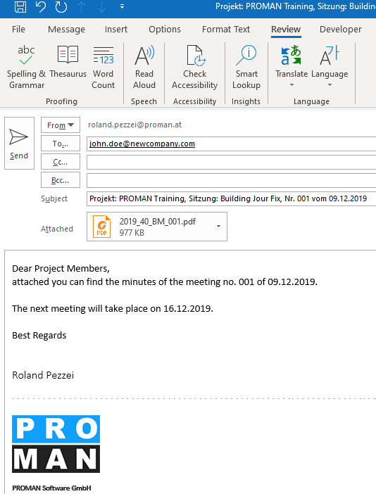

Further functions
The application also supports many other functions:
- Search and reporting to find or to print out sub-areas of protocols
- Agenda and invitation
- Prepare meeting with your own comments for each item
- Live logging with beamer view
- Import points from external cross-referenced sessions
- ..

Layout and print settings
Further information on the possible layouts and print settings can be found directly in the training documents of your version:
https://www.proman.at/proman_x_releases/currentversion/

If you have any questions, our team at the hotline will be happy to answer them:
support@proman.at
International or AT +43 1 478 05 67
from Germany 0800 589 0129
We are happy to support you.
Your PROMAN Team

